**MEMORANDUM**

Date: October 30, 2012

To: Melani Howard; Dr. Thomas Hardy, Meadows Center

From: BaCon

CC: Dr. Yongmei Lu, Texas State University

Subject: Progress Report

**Environmental Health of San Marcos River Watershed**

Basin Conservation has written this memo to inform the Meadows Center and the City of San Marcos of the progress made since the original proposal was decided upon in the initial meeting. Included in this document is an overview of the reasoning behind the Environmental Health of the San Marcos River Watershed project, descriptions of accomplishments, updates on the current work status, as well as information about future work required for the project’s completion by the end of our timeline.

**Project Description:**

For the convenience of all parties involved, this section is a review of the purpose, background, and the scope of the Basin Conservation project for the City of San Marcos. This project explores the potential impact of the estimated growth of impervious cover in San Marcos from the present day until the year 2035 on the health of the San Marcos River Watershed.

**Background:**

The growth of San Marcos is inevitable with Texas State University and the surrounding cities of San Antonio and Austin expanding rapidly. This leads to an increase in construction of businesses, roads, and housing, which are all formed from such materials as concrete, metals, and asphalt. All of these materials are types of impervious cover, or land cover that increases the water runoff. This water runoff contains man-made pollutants like chemicals, pesticides, and litter. Increased impervious cover also prevents water from infiltrating the ground and filtering out the pollutants before it reaches the ground water. This type of pollution is known as non-point source pollution. Non-point source pollution greatly affects the health of local aquatic systems like the Upper San Marcos River Watershed and the Edwards Aquifer. The other form of harm to an aquatic system caused by increased runoff is the effect on the replenishment of water in the system, the rivers, and the aquifer. Both of these side-effects from San Marcos’ growth potentially harm the habitat of native species. The focus of this project is to preserve the health of the aquatic systems in San Marcos by aiming to maintain clean, clear water.

**Purpose Statement:**

Using the water standards from TCEQ and the criteria from specific endangered species, which will be explained further in depth later on in this progress report, work will be done by using the comprehensive land use and land cover (LULC) prediction of San Marcos’ growth as provided by the city of San Marcos’ Design Rodeo conference. This data will be used for studying the impact of increased impervious cover in the Upper San Marcos River Watershed. In the end, we will be able to provide interactive maps to demonstrate these outcomes via a website.

**Project Scope:**

The aquatic systems focused on for our project are those relevant to the City of San Marcos. Geographically, the extent is formed by the Upper San Marcos River Watershed which is the San Marcos River until its confluence with the Blanco River to the North of San Marcos and all of its tributaries. These areas are environmentally sensitive because the local aquatic ecosystems are fed by rain water and water stored in Edwards Aquifer. The project scope also includes the city of San Marcos, specifically the western side of the city and its developmental prediction for 2035.

**Schedule:**

Overall, our project is mostly on time though we did have some issues. The data acquisition went well, a majority of the data we required could be accessed through BASINS. The rest of the data we obtained, like species research, was found online, please see the data section below. We ran into several problems during our initial BASINS training. The training started off well, however soon after we ran into a data input issue and our progress stalled. For this reason the time is now extended for BASINS training until the end of October. This should not interfere with the rest of our project since the tutorials will help us set up for the data analysis portion, which should now take less time. The timing for web design, presentation, and final editing should remain the same.

**Timeline:**

October 3-12, Data Acquisition

October 15 - 31, BASINS training

November 1 - 16, Data Analysis

November 19 - 30, Web design and preparing the final presentation

December 3-7, Final editing

  

**Data:**

The data acquisition for this project has been successfully completed. We should now have all the information necessary to complete BASINS training and to begin our data analysis. Most of the data has been or will be downloaded directly through BASINS including weather and climate data, a digital elevation model, and census/TIGER line data. Land use data could be downloaded through BASINS as well, but instead the land use and land cover data we are using is provided by the new City of San Marcos comprehensive plan obtained through the Meadows Center. BASINS has an option to download the National Hydrography Dataset plus (NHDplus) data as well, but it was discovered to be faulty and not compatible with the program. As an alternative, we obtained the NHDplus data from USGS, but again we ran into difficulties while trying to incorporate this data into BASINS. We were finally able to acquire working NHDplus data through assistance from the Meadows Center. Other data that we need for the production of maps were spatial data such as county boundaries and stream layers. Those were obtained through the Texas General Land Office and Texas State University.

In our project, we will endeavor to determine when the water quality will be negatively affected by the predicted increase in impervious cover. Specifically, we decided to focus on the protection of the Fountain Darter and the Texas Wild Rice. Originally, we also planned to include the Texas Blind Salamander, but information on this species is scarce. We reason that if the Fountain Darter and Texas Wild Rice are protected, the Blind Salamander and the other native aquatic wildlife will be as well. Reading through research papers, we learned of the flow regimes and temperature thresholds necessary to sustain the life of the two specified endangered species. Guidelines for further water quality requirements were obtained through the Texas Commission on Environmental Quality. These guidelines include such parameters as dissolved oxygen, sulfide, and temperature levels.

**LULC Maps:**

The land use and land cover data will be at the core of our project. We decided to showcase the present and predicted LULC percentages in San Marcos in a couple of maps. The first map shows the percentages as they are today in the Upper San Marcos River Watershed. The city of San Marcos has the highest impervious cover out of the area. The second map shows the predicted LULC for San Marcos in the year 2035 and the impervious cover around the city is predictably expected to increase dramatically.

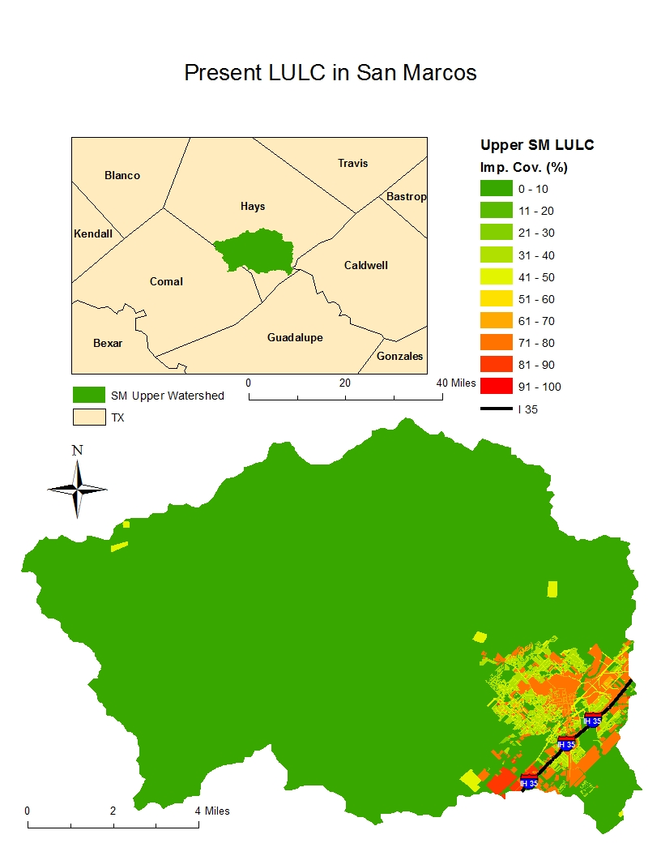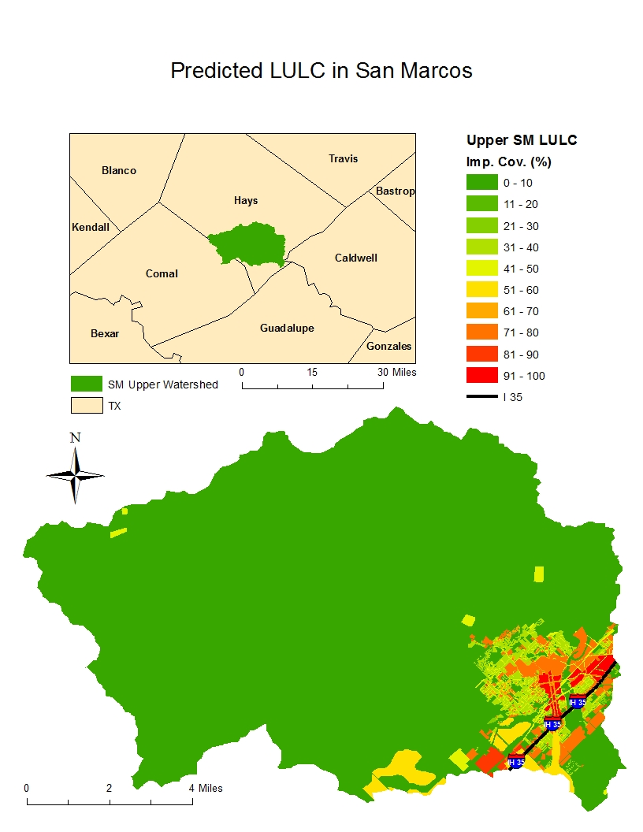

**BASINS:**

Over the past couple weeks BaCon has focused on BASINS training from the EPA website. So far, the training has covered basic commands and overall differences between BASINS and ARCMap 10. The advantageous aspects of working with BASINS is from its ability to download important data directly from the EPA as well as being able to take advantage of its water modeling capability using the HSPF model.

As a team we did run into some issues while downloading and displaying NHDplus data. The link from the EPA website unfortunately did not work. This ruined the initial plan for downloading directly from the BASINS program. We attempted to insert the data manually using NHD plus data from the United States Geological Survey (USGS), however, the data was not formatted to work with BASINS. After meeting with Kristina Tolman to discuss the issue, we were able to acquire the NHD plus data for the San Marcos watershed.

**Data Analysis:**

We have yet to complete the data analysis portion of our project. It will include running all our collected data through BASINS repeatedly to obtain the necessary results. This will display changes in land use along with impervious cover percentages. We intend to insert the data from the Upper San Marcos River Watershed into the HSPF model in order to display results based on the environmental impacts caused by the increase in impervious cover. After accomplishing this we can then effectively evaluate any changes which will be detrimental to the health of the Edwards Aquifer Recharge Zone as well as the harm done to the endangered species we mentioned earlier in the proposal and progress report.

**Final Deliverables:**

Although not on the schedule in the immediate future, we have been looking at options for the webpage when presenting our final project. We will use the Dreamweaver application for its completion. The page will be simple, easy to navigate, and include interactive components for the map. This will be provided with our final deliverables and the website will be included as part of our final presentation. The final presentation will contain all the details on our project’s outcomes and all the necessary data and maps. We will also have a large poster showcasing our procedure and findings. Last but not least, we will have a CD with all the above mentioned information and the necessary Read Me file and an instruction file.

**Conclusion:**

Team BaCon has been working diligently and has been following the original timeline of the project as closely as possible. Unfortunately our progression was hindered by data mishaps involving BASINS, which prevented the team from finishing the BASINS training as planned according to our schedule. In order to remedy this, a few more days have been allotted to BASINS training. This was deemed necessary since it is essential to the success of the project. All of the spatial and weather data we needed is acquired as planned. Research on the endangered species chosen (the Fountain Darter, Texas Wild Rice, and the Texas Blind Salamander) has been accomplished with the exception of difficulties with locating detailed and appropriate information on the Texas Blind Salamander. We do not believe this will harm the project’s ultimate goal and are positive we have sufficient information to analyze the water standards under consideration in an efficient way. The progress on this project has not been completely smooth, but the work continues and obstacles have been overcome through hard work, communication, and cooperation. We do not anticipate any huge hindrances in our future work, but expect that we will be able to master any unexpected problems through determination and collaboration with the Meadows Center.